Chapter 3, Problem 86.

For the simplified transistor circuit of Fig. 3.122, calculate the voltage v_{o}.

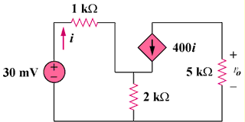
47 mV

Figure 3.122
For Prob. 3.86.

